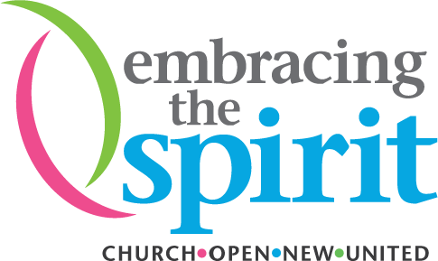
Growth Grants Application
Contents
Overview 1
The Opportunity 2
Market Analysis 3
Leadership / Management Team 4
Spiritual Impact 5
Marketing 6
Operations 7
Financials 8

Your Name* (both first and last name)

United Church/Organization’s Name (Payee)*

Full Mailing Address*

E-mail*

Phone

Overview
How much money are you asking for?
Please describe your initiative in 250 words (this is to be used in The United Church of Canada’s communications about your initiative)

URL (Web address or social media to reference in communications)

The Opportunity
What is the problem or opportunity that you are addressing?

How big is this problem?

How are you going to solve this?

What is unique about the idea that you are proposing?

Does this fully address all of the needs of the stakeholders? How?

How will this make a difference in the neighbourhood? What is the social, financial, ecological, and spiritual impact?

Is this a good fit with your current mission? Why? How will this initiative impact what the community is saying about your church?

Where do you see your idea in five years from now?

What do the next three to six months look like?

Market Analysis
What were some initial indicators that this was a good idea for your neighbourhood?

Who are the people that need this? How many people need this?

Who are your competitors? Is anyone else doing this?

What market research have you done in order to validate that this idea will work?

What are some potential risks? And how would you mitigate or overcome these?

Leadership/Management Team
Who is the manager? What is their background and experience?

Who is part of the team?

Are there volunteers?

What other management/staff are required?

Who are your strategic partners? What type of relationship do you have?

Spiritual Impact
How will this increase the meaning and purpose of participants’ lives in a way that reflects the church’s theological foundations?
- Faith
- Justice
- Ecological integrity
- Radical hospital
- Inclusive intercultural
How will this increase the engagement of the community in partnership with the faith community?

How many people will be impacted by this both with and without the faith community?

How are the values of The United Church of Canada reflected in the project?

Which of the UN’s Sustainable Development Goals (SDGs) are being impacted by this idea (select all that apply)? Learn about the SDGs: https://sustainabledevelopment.un.org/sdgs.
  - No poverty
  - Zero hunger
  - Good health and well-being
  - Quality education
  - Gender equality
  - Clean water and sanitation
  - Affordable and clean energy
  - Decent work and economic growth
  - Industry, innovation and infrastructure
  - Reduced inequalities
  - Sustainable cities and communities
  - Responsible consumption and production
  - Climate action
  - Life below water
  - Life on land
  - Peace, justice and strong institutions
  - Partnerships for the goals

Marketing
How will you let people know about your organization? What marketing tools will you be using?

How, when, and where will it be delivered?

Is there a price? What is the price?

Operations
What do you need to get started? Equipment? Resources? People?

What are you going to partner for?

What else are you planning to do to get started?

How does the project connect with the environment?

Is this project scalable? How well can the venture sustain growth?

Financials
What are some ways that you could generate revenue?

What are your start-up costs?

What are your ongoing costs?

How do you plan to become sustainable?

How will you measure success? Consider financial, spiritual, ecological, and social impacts.

Have there been donations for this initiative? Or is there potential for donations?

Has another organization provided funding for this initiative?

What do you need from Embracing the Spirit to get this off the ground financially?

