2024 Asian Heritage Month Worship:
Deep Spirituality • Bold Discipleship • Daring Justice
Contributed by Collaborating Asian Networks in The United Church of Canada:
Hong Kong, Korea, Philippines, Taiwan,
Global Partnership Team in General Council in The United Church of Canada,
and more people of God who live in blessings of Asian heritages
in faith, love, justice, and hope
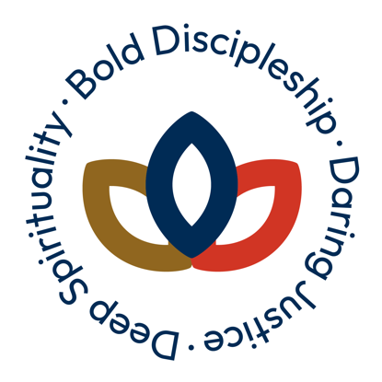

Deep Spirituality

Musical Prelude

Hymn 1
Voices United 599 “Living Christ, Bring Us Love”

Welcome
(The leader: Consider inviting the people to extend their arms to God and one another.)
The grace of God be with God’s people, who worship God with all our hearts and minds.
The grace of God be with the oppressed, the poor, the marginalized, the alienated, those who are suffering in this global community, and the groaning creation due to injustice and exploitations.
We open our arms to welcome all, as it is right and good to extend our arms to one another.

Announcements
These 2024 Asian Heritage Month worship resources have been prepared through the collaboration of various Asian groups within The United Church of Canada. We have invited contributions with the themes of the United Church’s new Vision—Deep Spirituality, Bold Discipleship, and Daring Justice—to celebrate Asian heritages.
We would like to reaffirm our dedications to equity, inclusivity, and the liberation of God. Communities of faith are warmly invited to incorporate video clips, stories, and images from these resources for worship services in 2024 Asian Heritage Month.

Acknowledgement of the Land
(Every community of faith is to acknowledge the land accordingly.)

Acknowledgement of Asian Heritage
Canada’s cultural richness owes much to its vibrant Asian heritages, woven with tradition, resilience, and innovation. Asian Canadians have significantly shaped the nation’s history and identity. Celebrating this heritage acknowledges countless contributions, perseverance, and ongoing impact on Canadian society. From cuisine to literature, art to technology, Asian Canadians have left indelible marks on every aspect of Canadian life, enriching the nation. As we commemorate Asian Heritage Month, let us reflect on the past, celebrate the present, and envision a future of inclusivity and equity, where every voice is heard and valued.

Lighting Christ Candle
We light this Christ Candle here and now to celebrate the life-giving power of the Holy Spirit sent by the Risen Christ, who is the embodied Creator. When we follow the Way of liberating wisdom, peace and joy shine even in our times of wandering and our times of suffering.
The Holy Spirit enlightens us in this shining Christ Candle for giving life through the blessings of Asian heritages.

Call to Worship
Come!
Come to the place where God listens!
Come as humble as we are
Broken, whole
Sick, well
Come!
Come to sing!
Come to cry!
Come to hear!
Come to see!
Come to meet God to be a new creation!
God is here.
We are here.
God is giving us peace where we worship God.
We praise God!
Let us worship God with all our hearts and minds and bodies!
Amen!

Hymn 2
VU 34 “Come Now O God of Peace (O so-so)”

Affirmation of Faith
We believe in God, who struggles and journeys with the people and creation.
We believe in God, who liberates all from bondage, suffering, and oppression.
The God whose compassion and solidarity transcend the boundaries and limits imposed by this world.
We believe in God, who edifies and sustains all who aspire to and dream of abundant life.
The God who has prepared for all to share and enjoy the abundance of the whole universe.
We believe in the Triune God, whose revelation and presence are manifest from age to age.
The God who accompanies us on the paths toward peace, justice, and abundant life for all. Amen

Prayer
O, God, you are the Source of life and peace in heaven and on earth.
Pour out the grace of your peace on a world troubled by war and hatred.
Extinguish enmity between humans, and pour into the hearts of all humility, peace, and goodness. Calm those who are fighting, and give them wisdom. Give help to those who are suffering. Give protection to the refugees and homeless. Give comfort to the alienated and sorrowful. Give us all the will and strength to help, with all our hearts, our brothers and sisters who are suffering from war, injustice, and exploitation.
Blessed are the peacemakers, for they will be called children of God.
Teach us to seek to acquire peace of heart and peace among peoples, for in the heart in which peace is found there is no longer enmity, dominion, or fear, but the consolation of the Holy Spirit, love of God, and love of our neighbours.
For this we humbly pray to you, O Christ our God, for peace among peoples and for the welfare of the whole world, that we may live in harmony. Amen.

Scripture Reading
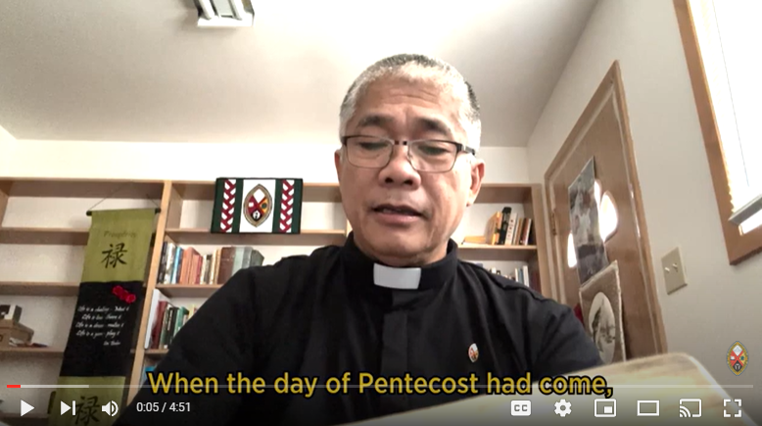
Watch the Asian Heritage Month: Acts 2 video.
This scripture reading is done in seven Asian languages read and recorded by ministry personnel who live in Asian heritages in The United Church of Canada.

Acts 2:1‒21
Filipino (vv. 1‒3), Cantonese and Hong Kong style English (vv. 4‒7), Nepali (vv. 8‒11), Bunun(vs. 12‒15), Korean (vv. 16‒18), Japanese (vv. 19‒21)

Hymn 3
VU 320 “Mothering God, You Gave Us Birth”
or VU 380 “She Comes Sailing on the Wind”

Bold Discipleship

Proclaiming Good News

Sermon Sparks
For celebrating Asian Heritage Month, you have the option to integrate the scripture passage from Revelation 7:9‒10 into your sermon. This passage beautifully ties in themes of diversity, unity, and the empowerment of the Holy Spirit.
Here’s a suggested outline for incorporating it into your message:
Begin by referencing the significance of Pentecost, highlighting how the Holy Spirit empowered the disciples to proclaim the gospel in diverse languages.
Connect this to the vision in Revelation depicting a diverse multitude standing before the throne of God.

Themes to Explore
Gift of Diversity: Reflect on how diversity is a precious gift entrusted to us, reflecting the beauty and complexity of God’s creation. Emphasize how each culture brings unique perspectives and expressions of faith, showcasing the deliberate manifestation of the Spirit’s creative work.
Manifestation of the Spirit: Discuss how the vision in Revelation reveals that diversity is not a barrier but a testament to the boundless creativity of the Spirit. Highlight how the unity of our spiritual being transcends earthly divisions, affirming the sacredness of every human soul and the interconnectedness of all creation.
Human Fragility and Interdependence: Explore how diversity also highlights the fragility of our human condition and our interdependence. Discuss how shared struggles and vulnerabilities unite us as one human family, emphasizing our collective responsibility to care for each other.
Call to Transformation: Encourage reflection on the call to transformation, both individually and collectively. Discuss how the Spirit empowers us to transcend cultural barriers and embrace the fullness of our shared humanity. Challenge listeners to engage in acts of love, compassion, and solidarity, working towards a world where diversity is celebrated, justice is upheld, and all are welcomed as beloved children of God.
Summarize key points, and invite listeners to embrace the message of Pentecost and Asian Heritage Month, recognizing the beauty and value of diversity while striving for unity and justice.

Sharing a Message: Solidarity with Partners and Siblings in Asia
One of my favourite hymns is Voices United 578: “As a fire is meant for burning…so the church is meant for mission.”
That hymn, its words, and its vision reflect what I learned very early in my faith journey, from Asian siblings. The Rev. Dr. Lee, In Ha was a Korean resident in Japan, a Christian leader of the Korean Christian Church in Japan. He inspired his people—and me—with his understanding of what God’s church is called to be: “Both ‘sanctuary’ and ‘sign,’” Dr. Lee explained.
Providing sanctuary is part of the church’s calling, said Dr. Lee, to be what others might call “beloved community”: a place where all belong, where all experience acceptance, love, and home. Church is a place where relationship with God and with one another is nurtured and precious. A place of guidance, nurture, correction, and deep compassion.
Dr. Lee, In Ha taught that Christians fail in our calling to be God’s church, however, if we stop there. Church cannot be only sanctuary. It must be more than beloved community. Dr. Lee taught that God’s church must also be a sign in the world, calling people in and then sending people out—to be salt and light in society, to act for compassion, love, and justice for all of God’s precious creation.
From the multi-faith reality of Asia, Asian siblings have taught me that mission is not defined by going out or doing outreach. I have learned that mission is about being called into relationship with those around us, discovering where God is working, how God is working through others, and joining with others to participate in God’s mission of abundant life for all. We know we gain more vitality when we look outwards—when we engage with one another in efforts towards life.
May we listen deeply to one another, and especially as we commit to deeper solidarity with Asian siblings. May we join with each other so that God’s church is both sanctuary and sign.
“The church exists by mission, just as a fire exists by burning.”

Prayers for People of God, Prayers of People of God
We would like to pray together for all people of God who are suffering due to injustice in Asian countries in global communities, especially people in Myanmar, India, Yemen, Afghanistan, Palestine, Philippines, Hong Kong, Korea, and more.
These prayers embrace diasporas and refugees who could not but leave their home countries to search for new homes in global communities due to life-threatening oppression.

Prayers for People of God (Responsive Prayer)
God, because we are a people that has been disrespected, we need our names to be said out loud at this time.
Confer on us dignity, to restore the images of God on us.
Because we have been victims of violence that takes away lives, peace, health, and dreams, at this moment we need our many, many stories of pain to be heard, loud and clear.
Confer on us the truth, to receive restoration.
Because we have been victimized by the same power that humiliates us when asking for justice, we need the guilt of those who once attacked us to be publicly recognized in front of the world.
Confer on us, body and soul, face to face, to receive and give…
You have said that whoever manages to see your face dies; show yourself to us as a verb and an action.

Prayer of the People (Unison)
Gracious and Loving Creator,
As we gather in this sacred space, our hearts overflow with gratitude for the vibrant tapestry of cultures that grace our Canadian mosaic. During this Asian Heritage Month, we lift our voices in prayer, honouring the enduring heritage and invaluable contributions of our Asian-Canadian siblings.
We give thanks for the resilience and fortitude of those who have traversed distant shores to make Canada their home. May their journeys inspire us to cherish diversity and foster unity within our communities.
We humbly acknowledge the trials and injustices endured by Asian Canadians, both past and present. Grant us the wisdom and courage to stand firm in solidarity against all forms of discrimination and bias.
Bless those who tirelessly champion understanding, celebrate diversity, and nurture inclusion. May their tireless efforts sow seeds of harmony in a society where every individual, irrespective of ethnicity or origin, is esteemed and honoured.
Guide us as we endeavour to construct bridges of empathy and compassion across cultural divides. May our ears be attuned to listen intently, our words be seasoned with kindness, and our actions be guided by justice, leading us to walk hand in hand in peace and harmony.
In this sacred moment of worship, let us be mindful of the interconnectedness of all humanity, bound together in love and solidarity. May our hearts be receptive to the beauty of every culture and the inherent dignity of every soul.
We offer this prayer in reverence and humility, invoking the name of all that is sacred and divine. Amen.

Prayer of the People
(This prayer is from Christian Conference of Asia’s worship for people in Myanmar on May 12, 2024, Asia Sunday.)
Leader: God of region and of world, for our land now we pray, humbly seeking your blessing, our God.
Voice 1: O God, we pray for the violence to end and for peace to prevail in Myanmar.
Remember your people struggling in the land torn by conflict.
We pray that essential aid will reach people in need.
We pray you would help and guide children in Myanmar to learn well and flourish.
We pray in solidarity with the minority Christian population in Myanmar.
We pray for all churches as they support their communities.
We pray for restoration of democracy and for God’s peace, justice, and righteousness to be established in Myanmar.
We pray, O God, guide the leaders in Myanmar to open paths of dialogue that will reconcile, heal, unite, and build anew the nation of Myanmar.
Leader: God, we give you thanks and praise for your never-ending love offered to us.
Voice 2: We ask you to grant your mercy to the nation and people of Myanmar,
that sadness may turn into joy, aggression into amity, despair into hope, and anxiety into calm,
that the people may be reconciled.
God of just and lasting peace.
We implore your help for Myanmar and its people, and for the worsening human rights situation.
We pray for justice for those who are killed during the conflict.
We pray for the release of political prisoners who endure the pains of torture and violence.
We pray for comfort of the families of the civilians killed due to indiscriminate attacks.
We remember in our prayers the poor, who are most harshly affected by the political turmoil.
We pray for strength for those who are forcedly displaced, for the needy who lack the basic services due to the blockade against humanitarian aid organizations.
Together: In Jesus’ name we pray, Amen.

Invitation to Offering
O God of love,
Let us live in the love you have planted in our hearts.
O God of justice,
Let us act in the justice you have enacted with our bodies.
O God of care,
Let us care for the creation you have created and cared for.
Let us be, live, and follow as the Way of the Risen Christ in the Holy Spirit for caring for God’s creation.
We offer our lives to be disciples here and now in this worship.
Bless this offering of our hearts and minds and bodies.
We pray in peace and joy, Amen.

Daring Justice
Communities of faith could use these resources for 2024 Asian Heritage month worship:
- “Asian Heritage Month: Gold ribbons show hope and solidarity amid anti-Asian violence”
- “Becoming an Anti-Racist Church in the Land of Living Skies: A Patchwork Quilt Sermon”

The Lord’s Prayer on the Day of Pentecost
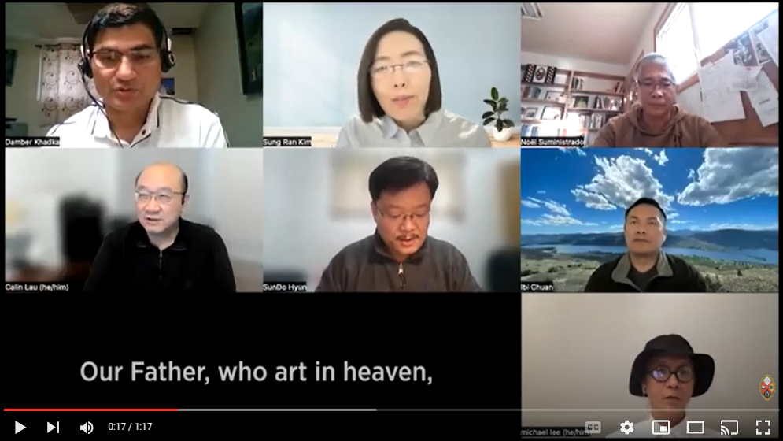
Watch The Lord’s Prayer in Asian Languages video.

Blessing and Sending Forth for God’s Liberation for All Creation
May God the Creator take away
your pain and loss.
May Christ shield you
in your sorrow and fear.
May the Spirit carry you
each day of your life.
And many blessings leading you
to the fulfillment of your dreams
give you peace in your heart.
Now go and live in peace, love, and joy of
our Creator, the Risen Christ, and the Holy Spirit. Amen.

Hymn 4
VU 698 “With the Wings of Our Mind” (video in English with Korean subtitles)

Musical Postlude
“Flying Elephant” by HyunJin Kim

Contributors
Organizers: Sung Ran Kim, SunDo Hyun, Co-chairs of The United Church of Canada Korean Network
Acknowledgement of Asian Heritage: Damber Khadka, Congregational Minister, Valley Pastoral Charge, Manitoba
Affirmation of Faith Prayer: From Christian Conference of Asian worship for Myanmar in 2024

Scripture Reading
Filipino (vv. 1‒3): Noel Suministrado
Cantonese (vv.4‒7): Calin Lau
Hong Kong style English (vs. 4‒7): Michael Lee
Nepali (vv. 8‒11): Damber Khadka
Bunun (vv.12‒15): Ibi Chuan
Korean (vs.16‒18): Sung Ran Kim
Japanese (vv. 19‒21): Mari Akiyama
Sermon Sparks: Damber Khadka, Congregational Minister, Valley Pastoral Charge, Manitoba
Sharing a Message: Patti Talbot, Team Leader, Global Partnership Program in General Council in The United Church of Canada

Prayer of the People
Damber Khadka, Congregational Minister, Valley Pastoral Charge, Manitoba
“Prayer Responsorial Healing” from the Council for World Mission
Christian Conference of Asia worship for Myanmar in 2024
Musical Postlude: HyunJin Kim, youth in Alpha Korean United Church, composed this music called “Flying Elephant” in grade 11.

