Telling the Story of Your Ministry:
The Narrative Budget
Do you know the top three reasons why people financially support your community of faith?
- Shared cause: Donors look for organizations with which they have a heart connection―a shared cause that makes the organization a compelling recipient of funds.
- Ministry efficiency: Church donors need continual evidence that they are giving money to a financially efficient ministry. Communities of faith must strive to prove this to donors.
- Ministry influence: Wanting to make a difference―to live a life of significance. People no longer give to the church simply because it is the church! Each community of faith must prove that it is worthy of donations through the mark it leaves on the world.
And yet comments like these are heard all the time, even from some church leaders and ministers:
“Every month I try really hard to understand the financial statement review at our church council meeting, but I get lost in a sea of numbers.”
“I hear the presentation of our church budget every year at our annual meeting, and I still don’t know where all the money goes.”
If you have heard comments similar to these, consider telling in a new and expanded way the story of how your community of faith spends its money for ministry programming.

What Is a Narrative Budget?
- A narrative budget tells a story of the mission and ministry of your community of faith that integrates dollars, people, and mission into one portrait.
- A narrative budget includes salary, building, and office expenses as part of the cost of individual ministry programming categories. This document covers five categories: Worship, Christian Development, Pastoral Care, Mission & Service, and Outreach. You will want to choose category headings that describe your community of faith’s programs.
- A narrative budget is vision-driven, providing glimpses of how your community of faith lives out in practical ways the broad brushstrokes of your vision statement. This narrative connects your story with the story of the Christian faith. Jesus used narrative and story to excite people to follow God’s Way. Within all the practical details Jesus would name, he always named that larger vision of being a people of God.
- A narrative budget does not replace a financial statement. It builds upon it and reshapes the same information within a narrative.
- A narrative budget usually tells the story of expenses, based on the assumption that income received by your community of faith is spent for expenses. It could be helpful to include in your narrative a paragraph that names how you raise the money (e.g., offerings, fundraisers), indicating that using these sources of revenue affects how, and how much, you can spend.

Why Do It?
In many communities of faith, program committees share full and exciting visions of ministry―worship services, educational opportunities, events, and outreach projects. These committees, once a year, present budget requests to the finance folks asking for the amount of money they think they need. Finance prepares the money picture, and others prepare the ministry programming pictures separately—and neither one tells the whole story.
Preparing a narrative budget is the key to overcoming this separation of money and ministry, integrating dollars and ministry programming.
Narrative budgeting encourages church leaders to highlight the theology of giving and receiving―a theology that emphasizes the abundant gifts given to us by God and the abundant gifts we in turn want and need to give to God. This is why you exist as a community of faith! This is what you have to celebrate! Your time! Your money! Your whole selves given as a gift to God!
There is a basic stewardship understanding that each of us has an innate need to give. When you tell your story, the reader―the giver―will want to respond by giving. Often, this natural desire to give will lead to other forms of commitment.
Yes, you have a story to tell! And you have dollars attached to your story. You seek a response from those who need to give, developing a commitment not to a financial statement but to a faith story and the particular way that faith story is lived out in your community of faith.

Who Is Involved?
When you are creating a narrative budget, involve as many people as possible.
- The treasurer, finance committee and trustees provide financial data.
- Committees need to develop the narrative story of their work.
- Members of your staff, including ministry personnel, highlight how they spend their time in each program area.
- Members and adherents can share testimonials of their commitment to particular areas of ministry programming.
- Individuals who like to write and compile stories from all of these sources of information can be asked to create the narrative document.
Spend some time asking yourself who needs to be involved in creating your story. Think together about who “everyone” is in your setting.

When and Where Do You Use It?
Remember those two quotes on page 1? What opportunities do you have in your community of faith to share this narrative and clarify the financial picture?
Here are four occasions, but you will think of others:
- The administrative work of the community of faith that is carried out by the board/council can be enriched by the existence of a narrative budget. Creating a narrative budget pamphlet that parallels the financial statement integrates finances and budgets with ministry programming so programming isn’t forgotten in concerns over money.
- At your annual meeting, hand out the narrative budget information pamphlet along with the financial statement. This provides a complete overview of your ministry programs and a detailed account of the finances of your community of faith at the time you are asking for approval of the upcoming budget. Consider asking a few people to take photos throughout the year and using them in a PowerPoint presentation as a visual way of telling your story.
- Narrative budgets are integral and necessary pieces in any well-developed stewardship program. It is important to help each member and adherent in your community of faith develop a picture of the whole mission of your church, particularly when you are asking them to give their time and their money. You are so much more than buildings; you are so much more than staff; you are so much more than office supplies. You are a people of God with an opportunity and obligation to respond to God’s call. Tell the story of how that response takes shape through the ministry programming of your community of faith. In this way, you focus your stewardship program on the core message of celebrating God’s gifts to us, and offering in return our gifts to God.
- A narrative budget is a key communication tool in an information packet for visitors and new members. It is never too early to begin telling a story that draws people into wanting to know more and to become more involved.
These are simply starting points. Take some time to create your own list of moments when you can effectively use a narrative budget document.

Five Steps to Writing a Narrative Budget
There are many formats you can use: visual components such as PowerPoint presentations, slides, photos, even videos, for instance. Many communities of faith use a format that can also be posted on their website. This document includes a sample on the last pages that assumes a pamphlet created on legal-size paper.
Whatever the format, there are five basic steps:
- Get ready! Gather a small team to work on your narrative budget. Pray together.
- Review your mission statement to see if it is brief enough to be used on the cover.
- Create profiles of ministry programming. Try to keep to as few categories as possible. The sample at the end of this document includes five generic areas : Worship, Christian Development, Pastoral Care, Mission & Service, and Outreach.
- Work with the financial statements. Your narrative has the same totals as the financial statements, just shaped into a different configuration.
- Allocate expenses to each ministry area.

Creating Profiles of Ministry Programming
Writing the narrative takes some skill. The facts must be right, and the style should draw people into the story. Pictures, personal comments, and quotes can add interest to the presentation.
The sample at the end uses a straightforward narrative that includes a description of each area of ministry programming (e.g., Worship) and then adds in a list of specific examples of events. You will notice that with Worship the list includes baptisms, weddings, and funerals as well as ushers, greeters, and worship bulletins―a combination of ministerial duties, volunteer activities, and office supplies.
In each area you have chosen as a ministry program area, highlight your understanding of that ministry and how you live it out in practical ways. The generic sample is simply one format. Choose your own category titles, then be creative in your writing and presentation!

Allocating Expenses to Each Ministry
In the sample pamphlet (you can download the template at www.united-church.ca/stewardship), the back page presents a budget of $154,300 for Anywhere United Church. Column 1 is the annual budget as it appears on the financial statement. This budget is the source of the amounts in the narrative columns (columns 2, 3, 4, 5, and 6).
Example 1
The total expense (salary, benefits, travel, etc.) for ministry personnel is $48,000. In conversation with the minister, the Ministry and Personnel Committee would ask the minister to determine a rough estimate of time spent in each category of programming. This example indicates approximately 40% spent on matters related to Worship, 23% to Christian Development, 18% to Pastoral Care, 17% to Mission & Service, and 2% to Outreach.
Once percentages are figured out, it is easy to determine the amounts to allocate. In line 1, 25% of $48,000 is $12,000 and is assigned to Christian Development. Similar calculations provide the figures for Worship, Pastoral Care, Mission & Service, and Outreach.
Example 2
The fourth budget line item lists the organist’s salary at $20,000. In this community of faith, the organist has responsibility only in the ministry of worship, so 100% of the expense is allocated to Worship.
The same deductive process is used with each budget line item. Only approximations are expected. The final picture emerges when all the calculations are done. In this example, you can see at a glance that Anywhere United Church spends 40% of its budget in worship programming, 23% in Christian Development, 18% in pastoral care ministry, 17% in Mission & Service, and 2% in Outreach.

In Conclusion
Leaders in every community of faith have a responsibility to share the story of their mission and how they live out their lives together as the church. As Christian communities, every community of faith has an exciting faith story to tell. A narrative budget can be part of this process, reshaping what seems to be simply an administrative task into an integrated story of your life as a community. How you raise money and how you spend it are defining characteristics of who you truly are. How you worship, nurture, care, and reach out offer more defining moments. A narrative budget helps you to keep before your members, adherents, and communities a picture of money and ministry offering faithful mission.
Everyone loves a story! Have fun developing and telling yours!

Resources
Narrative budget samples at www.united-church.ca/stewardship and in Called to Be the Church.
―Adapted from prior resources by Judith Johnson and Barbara Fullerton, with information from “How to Increase Giving in Your Church” by George Barna (1997).

Sample Narrative Budget
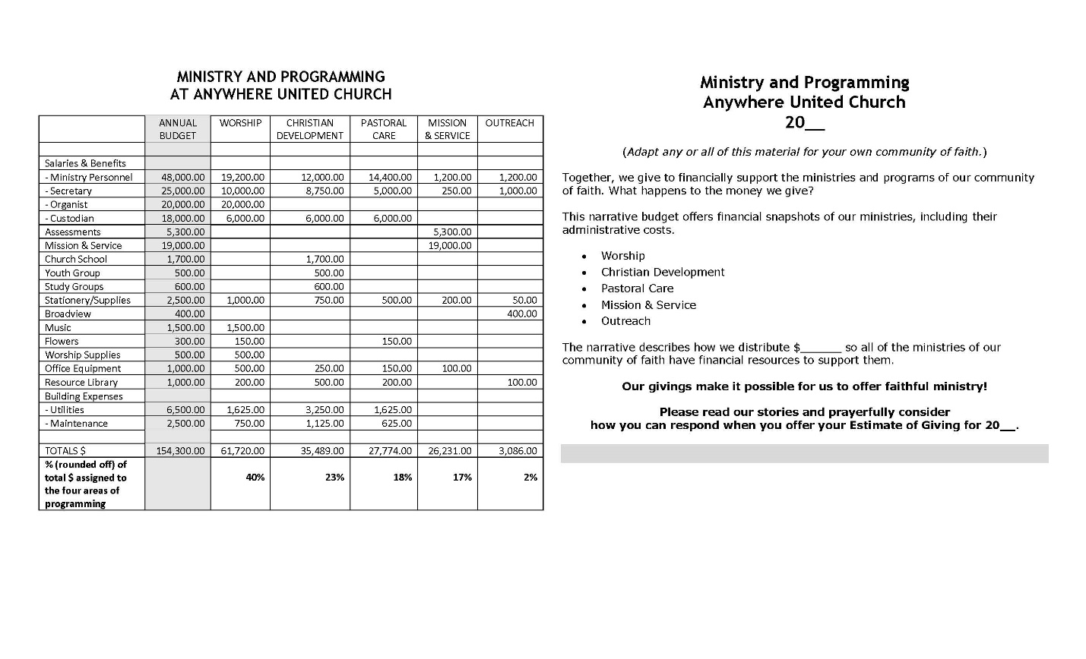
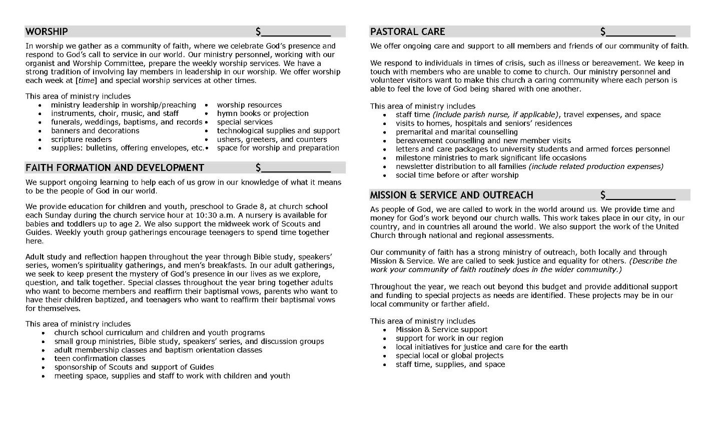

MINISTRY AND PROGRAMMING
AT ANYWHERE UNITED CHURCH
 | ANNUAL BUDGET | WORSHIP | CHRISTIAN DEVELOPMENT | PASTORAL CARE | MISSION & SERVICE | OUTREACH
Salaries & Benefits
- Ministry Personnel | 48,000.00 | 19,200.00 | 12,000.00 | 14,400.00 | 1,200.00 | 1,200.00
- Secretary | 25,000.00 | 10,000.00 | 8,750.00 | 5,000.00 | 250.00 | 1,000.00
- Organist | 20,000.00 | 20,000.00
- Custodian | 18,000.00 | 6,000.00 | 6,000.00 | 6,000.00
Assessments | 5,300.00 |  |  |  | 5,300.00
Mission & Service | 19,000.00 |  |  |  | 19,000.00
Church School | 1,700.00 |  | 1,700.00
Youth Group | 500.00 |  | 500.00
Study Groups | 600.00 |  | 600.00
Stationery/Supplies | 2,500.00 | 1,000.00 | 750.00 | 500.00 | 200.00 | 50.00
Broadview | 400.00 |  |  |  |  | 400.00
Music | 1,500.00 | 1,500.00
Flowers | 300.00 | 150.00 |  | 150.00
Worship Supplies | 500.00 | 500.00
Office Equipment | 1,000.00 | 500.00 | 250.00 | 150.00 | 100.00
Resource Library | 1,000.00 | 200.00 | 500.00 | 200.00 |  | 100.00
Building Expenses
- Utilities | 6,500.00 | 1,625.00 | 3,250.00 | 1,625.00
- Maintenance | 2,500.00 | 750.00 | 1,125.00 | 625.00
TOTALS $ | 154,300.00 | 61,720.00 | 35,489.00 | 27,774.00 | 26,231.00 | 3,086.00
% (rounded off) of total $ assigned to the four areas of programming |  | 40% | 23% | 18% | 17% | 2%

Ministry and Programming
Anywhere United Church
20__
(Adapt any or all of this material for your own community of faith.)
Together, we give to financially support the ministries and programs of our community of faith. What happens to the money we give?
This narrative budget offers financial snapshots of our ministries, including their administrative costs.
- Worship
- Christian Development
- Pastoral Care
- Mission & Service
- Outreach
The narrative describes how we distribute $______ so all of the ministries of our community of faith have financial resources to support them.
Our givings make it possible for us to offer faithful ministry!
Please read our stories and prayerfully consider
how you can respond when you offer your Estimate of Giving for 20__.

WORSHIP $____________
In worship we gather as a community of faith, where we celebrate God’s presence and respond to God’s call to service in our world. Our ministry personnel, working with our organist and Worship Committee, prepare the weekly worship services. We have a strong tradition of involving lay members in leadership in our worship. We offer worship each week at [time] and special worship services at other times.
This area of ministry includes
- ministry leadership in worship/preaching • worship resources
- instruments, choir, music, and staff • hymn books or projection
- funerals, weddings, baptisms, and records • special services
- banners and decorations • technological supplies and support
- scripture readers • ushers, greeters, and counters
- supplies: bulletins, offering envelopes, etc.• space for worship and preparation

FAITH FORMATION AND DEVELOPMENT $____________
We support ongoing learning to help each of us grow in our knowledge of what it means to be the people of God in our world.
We provide education for children and youth, preschool to Grade 8, at church school each Sunday during the church service hour at 10:30 a.m. A nursery is available for babies and toddlers up to age 2. We also support the midweek work of Scouts and Guides. Weekly youth group gatherings encourage teenagers to spend time together here.
Adult study and reflection happen throughout the year through Bible study, speakers’ series, women’s spirituality gatherings, and men’s breakfasts. In our adult gatherings, we seek to keep present the mystery of God’s presence in our lives as we explore, question, and talk together. Special classes throughout the year bring together adults who want to become members and reaffirm their baptismal vows, parents who want to have their children baptized, and teenagers who want to reaffirm their baptismal vows for themselves.
This area of ministry includes
- church school curriculum and children and youth programs
- small group ministries, Bible study, speakers’ series, and discussion groups
- adult membership classes and baptism orientation classes
- teen confirmation classes
- sponsorship of Scouts and support of Guides
- meeting space, supplies and staff to work with children and youth

PASTORAL CARE $____________
We offer ongoing care and support to all members and friends of our community of faith.
We respond to individuals in times of crisis, such as illness or bereavement. We keep in touch with members who are unable to come to church. Our ministry personnel and volunteer visitors want to make this church a caring community where each person is able to feel the love of God being shared with one another.
This area of ministry includes
- staff time (include parish nurse, if applicable), travel expenses, and space
- visits to homes, hospitals and seniors’ residences
- premarital and marital counselling
- bereavement counselling and new member visits
- letters and care packages to university students and armed forces personnel
- milestone ministries to mark significant life occasions
- newsletter distribution to all families (include related production expenses)
- social time before or after worship

MISSION & SERVICE AND OUTREACH $____________
As people of God, we are called to work in the world around us. We provide time and money for God’s work beyond our church walls. This work takes place in our city, in our country, and in countries all around the world. We also support the work of the United Church through national and regional assessments.
Our community of faith has a strong ministry of outreach, both locally and through Mission & Service. We are called to seek justice and equality for others. (Describe the work your community of faith routinely does in the wider community.)
Throughout the year, we reach out beyond this budget and provide additional support and funding to special projects as needs are identified. These projects may be in our local community or farther afield.
This area of ministry includes
- Mission & Service support
- support for work in our region
- local initiatives for justice and care for the earth
- special local or global projects
- staff time, supplies, and space

