Sample Response Card
Below are two sample layouts. Please modify to suit your needs.
[Name] United Church
Thank you for your generosity. You are important to us.
Name:
Preferred contact information:
It is my/our intention to contribute to the mission of God’s church by committing to the following financial support for the 12 months beginning . (date)
$ to local ministry and mission
per week per month
$ to Mission & Service
per week per month

Indicate method of giving and amount
Monthly Pre-Authorized Remittance (PAR) $
To change your PAR amount or start giving by PAR, please see the enclosed PAR form.
Offering envelopes $
Other: How? Amount $

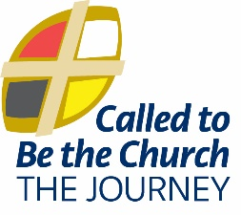 | Giving Program | Response Card
 | Name
 | Address
 | Email
 | Phone Cell
I/we intend to support God’s mission through |  | My/Our Method of Giving
[name] United Church |  | - Envelopes
Our Ministries $ |  | - Existing Monthly Pre-Authorized Remittance (PAR)
Our Building $ |  | - NEW Monthly Pre-Authorized Remittance (PAR)
Wider Church and World |  | - Other
Mission & Service $ |  | If NEW to PAR, you will be contacted by the Envelope
 |  | Steward to arrange to begin your monthly gifts.
Our Congregational Giving Goals |  |  | THANK YOU!  Please return this card  Before: [date]
- Grow Response Card submissions from x to y.
- Increase monthly PAR donors from x to y.
All information is gathered for the church’s ministry planning. It will be received and processed in a confidential manner by the Envelope Steward. You may change the amount of your gifts at any time.

