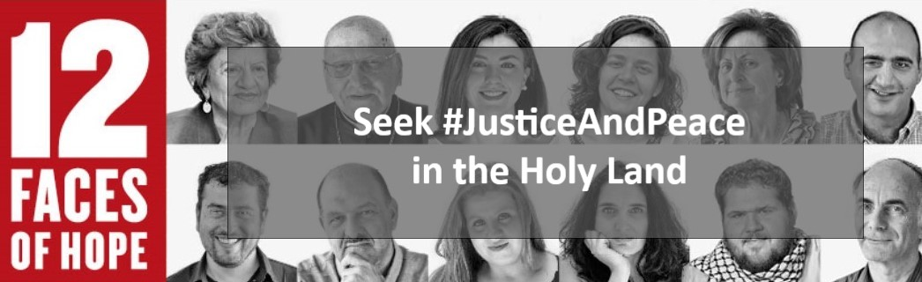
Half a century has passed since the six-day war when Israel occupied East Jerusalem, the West Bank, the Gaza Strip and the Golan Heights. Despite stalled peace processes and the sufferings entailed by the occupation, people still hope for a better future. Meet 12 people with different backgrounds sharing their hopes for justice and peace in the Holy Land.
oikoumene.org/what-we-do/seek-justiceandpeace-in-the-holy-land

