Called to Be the Church: Congregational Giving Program, 2020
Loving Our Neighbours
  - All in One Gratitude Sunday: A Single-Sunday Program
Worship Service 2
Sermon: Show Me 7
Children’s Time 10
Mission & Service 2019 Map 12

Worship Service

Prelude
(You may opt to play one of the videos from the Called to Be the Church program. The video of Chris Levan, Giving Thanks/Modelling Gratitude (on the United Church YouTube channel) is one idea. The video might be played in a loop as people gather for worship.)

Welcome

Acknowledging the Traditional Territory
Long before those of us who are settlers, and those of us who are descendants of settlers, came to this land, there were people here. Many Nations of people lived—and live—on the land we call Canada, given responsibility by the Creator to be stewards of this land and all that lives on it. We know these people as Indigenous.
Today, as we remember what it means to live thankfully, let us give thanks for the Indigenous peoples of this land—and let us remember that we worship God on the historic (and unceded) territory of the (names of the Indigenous people(s) whose territory you are in). As Christ’s people, let us be people of Love, of Truth, and of Reconciliation.

Call to Worship (Option 1)
Leader: We gather today, proclaiming God’s love and seeking God’s blessing.
People: God loves us with an immeasurable love. God is with us always, even when we are unaware, even when we feel lost or alone.
L: In gratitude we come, proclaiming our thanksgiving and seeking to live out our love.
P: In life, in death, in life beyond death, God is with us. We are not alone. Thanks be to God.
L: Thanks be to God. Let us worship God.

Call to Worship (Option 2)
(based on John 21:15–19)
Children of God, do you love the God who hovered over the face of the deep and called the worlds into being?
Yes, you know that we do.
Then feed God’s children.
Children of God, do you love the God who was revealed in the life, death, and resurrection of Jesus the Christ?
Yes, you know that we do.
Then take care of God’s children.
Children of God, do you love the God who breathes new life into us even as we gather this day?
Yes, you know that we do.
Then feed God’s children.
―Based on John 21:15–19. Written for Evangelical United Church of Christ, 1998. Copyright Katherine Hawker. Posted on Liturgy Outside. re-worship.blogspot.com/2013/03/call-to-worship-john-21-15-19. Used with permission.

Call to Worship (Option 3)
Leader: Christ asked Peter if he loved him.
People: Peter affirmed three times his love of the Lord.
L: Christ asks us if we love him.
P: We affirm our love of the Lord in our worship
L: Christ calls us to demonstrate our love in service.
P: Lord, help us to witness to your love in the ways in which we care for others. Amen.
―Source: ministrymatters.com/all/entry/3724/worship-connection-april-10-2016. Used with permission.

Opening Prayer (Option 1)
Generous God, giver of every good and perfect gift, we lift our voices today to express our thanks and praise. For health and strength, for family and friends, for our homes and this church community, and for your abiding and life-giving presence, we say thank you. For your love, which knows no bounds, and for empowering us to share your love with others, we sing your praise. Make us deeply aware of your presence today as we gather together to worship, in Jesus’ name. Amen.

Opening Prayer (Option 2)
Loving and generous God, you are the font of every blessing, the source of all we have. Your breath gives us life, your love gives us courage and strength, healing and compassion. You care for us like a loving parent and feed our spirits, our minds, and our bodies. We thank you for your abundance given freely to all.
But God, forgive us for wanting more, even when we have more than we need. Create in us new hearts to love our neighbours as much as we love ourselves. Help us to know that our abundance is for others’ needs. Great Teacher, write your law on our hearts. God’s abundance is enough for all if we share.
―From “Liturgy for a Labor Sunday Service” by the Rev. Ed Middleton, Cocoa Beach Community Church, United Church of Christ. Used with permission.

Hymn/Song of Praise
“Come, Let Us Sing” (Voices United 222) or “We Praise You, O God” (VU 218)

Children’s Time
(See below.)

Responsive Psalm
Psalm 138 (VU p. 860)

Scripture Lesson
John 21:15–19

Anthem

Sermon
Show Me (See below.)

Hymn
“Jesus, You Have Come to the Lakeshore” (VU 563) or “Will You Come and Follow Me” (VU 567)

Prayers of the People
Creating God, we thank you for the gift that is life: for the changing seasons, for the tiny seeds that in your Holy Mystery become life-sustaining food, cleansed air, beauty to behold, and life itself.
We thank you for the gift of life.
Loving God, we thank you for the gift of family, friends, and community—those who know us so well that they know when to hold our hand and when to let go. We thank you for those people who journey with us in our times of joy and especially in our times of sorrow.
We thank you for the gift of love.
Compassionate God, we thank you for holding us in troubling times. We pray for those who are journeying through illness, awaiting medical diagnosis, those with life-threatening and degenerative diseases. We know that we do not journey alone but that you are always with us.
We thank you for the gift of compassion.
Challenging God, we thank you for writing your law upon our hearts so that we are called to seek justice and to love kindness. Thank you for moving us to action and challenging us to be your hands and feet in a world so desperately in need of healing.
We thank you for the gift of challenge.
God of all time and place, we thank you for the gifts of life, love, compassion, and challenge. Help us to know that each small individual action together with another’s can make a difference to the world and make a world of difference. May your kingdom come on earth as it is in heaven.
We thank you for the gift of our call to discipleship.
Let us join our hearts, minds, and voices together as we pray the prayer our Saviour taught…
The Lord’s Prayer
―Cheryl Curtis and Faith March-MacCuish “Prayers of the People,” in Sunday 3 Worship in We Sing Thanksgiving (Called to Be the Church, program for 2017‒2018), page 81. Used with permission.

Minute for Mission
See Stories of Our Mission on united-church.ca.

Offertory Invitation
God’s blessings are all around us. For all that we have and for all that we are, we give God thanks and praise. We are now given an opportunity to be blessing to others. Through our PAR commitments, through our money, and through our time and talents, we now return to God, so that we might be a part of God’s love and God’s mission. Our offering will now be received.

Offertory Prayer (Option 1)
Gracious God, you call us to respond to your love with love. Accept these gifts we bring, and accept us that, together, we might be able to show your love and transform the lives of your people, in Jesus’ name. Amen.

Offertory Prayer (Option 2)
God of gift and giftedness,
Hear our prayers and receive this offering.
In these plates, along with monies given through PAR,
is our offering, a reflection of our “glad and generous hearts.”
By your blessing and our labours may this offering be transformed
into food for the hungry, drink for the thirsty,
clothing for the naked, community for the lonely.
And through our ministries may your good news be heard,
your peace be felt, and your love be known.
Amen!
―Bill Thomas and Cheryl Wood-Thomas, “Prayer of Dedication,” in Sunday 2 Worship in We Sing Thanksgiving (Called to Be the Church, program for 2017–2018), page 72. Used with permission.

Closing Hymn
“Take My Life and Let It Be” (VU 506) or “When Hands Reach Out Beyond Divides” (More Voices 169)

Commissioning and Benediction
Leader: Our worship is over, but now our service begins. We are called to go and live God’s love in the world.
People: We go in faith and in hope to feed Christ’s sheep and care for Christ’s lambs.
L: Go in peace, and may the love of God embrace us, the compassion of Christ challenge us, and the Holy Spirit guide us.
P: Amen.

Sermon: Show Me

John 21:15‒19
The story is told about a farmer who, on one warm summer night, was sitting on the front porch with his wife. The couple had been together for over 40 years. On that particular night, the farmer began to think about how much he appreciated his partner. They had shared so much together. She had been caring, supportive, patient, and forgiving. Overcome with emotion, he turned to her and said, “Wife, you have been such a wonderful partner that there are times I can hardly keep from telling you!”
Love and gratitude are wonderful emotions, but particularly so when they are spoken—when we express them aloud. The phrases, “Thank you,” “I really appreciate it,” “I really appreciate you,” and “I love you,” are very powerful! These words have the potential to grow our love and strengthen our relationships. To not express those feelings aloud is, therefore, an opportunity lost. And yet, the truth is that many of us do not express our love and gratitude very much at all. Even as a church community we don’t always say it enough. It is not that we don’t love one another, it is not that we don’t appreciate each other and what we do for God’s mission here at (name of your church), it is just that we don’t say it enough.
Note: Here, the preacher might take the opportunity to both offer specific thanks to the members of the congregation and/or have members thank one another. For example: “So today, in this spirit, I thought that we might begin our time of reflection with a little thanksgiving. I would ask you right now, if you are comfortable, to turn to your neighbours and say ‘Thank you for being here, and thank you for all the ways you live out your faith here in this church.’ (Give time for people to respond.) Let me now say to each one of you, thank you so much for your presence, and for the many ways you contribute to the life and mission of this church. Your time, your sharing of talents and leadership, and your contributions to both our local ministry and Mission & Service change lives every day and are very much appreciated. We are less without you. I am so grateful to be here, in ministry, with all of you. Thank you!”
Expressing our love and gratitude in words is important and often powerful. You want to know something else? It is also helps us, we who do the thanking! Indeed, there are many recent studies that show that focusing on our abundance and expressing our gratitude regularly make us happier and healthier as individuals and stronger as a church community. Diana Butler Bass, in her wonderful book called Grateful: The Transformative Power of Giving Thanks, sums it up beautifully: “In addition to heart health, gratitude has also been linked to emotional well-being, lower levels of anxiety and depression, decreased panic attacks and phobias, reduced risks of alcoholism and substance abuse, and longevity (yes, grateful people live longer). Researchers found that thankful people live happier lives as well.” So bottom line—don’t be shy! Say thank you! Say it often!
While focusing on our gratitude and expressing it aloud is necessary, we all know, however, that it doesn’t end there. Love and gratitude must also be lived out—expressed in our actions. We all know of cases where someone says “I love you so much,” but their actions are not consistent with their words. They give a mixed message. And we also know that when messages are mixed, people believe our actions over our words. So it is key to both say it and live it.
So, how do we express our love and gratitude to God?
We can say it aloud and we do, regularly through prayers, storytelling, and singing. Indeed, when you think of it, our worship services are often full of words of thanksgiving. But what about our actions? How do we show God thanks and love? For instance, when we have those incredible moments of thankfulness, when our hearts are overflowing with gratefulness and praise, what can we do to express our love and gratitude to God?
Actually, Jesus had something to say about that. When asked once what God expected of a believer, he said, “Love the Lord your God with all your heart, and with all your soul, and with all your mind…. And…” [here it comes] … “Love your neighbour as yourself.” (Matthew 22:37, 39)
Neither of those two commands were new to Jesus’ listeners. What was new was the way Jesus linked the two, in essence, saying to people, “You want to express your love to God? Then love one another, love your neighbour. Want to express sincere gratitude for all that God has done for you? Then reach out and care for all those God loves.”
In today’s lesson from John’s gospel we get a similar message. Jesus is speaking to Peter. It is after the resurrection. Jesus is about to leave this earth and he wants to ensure that the disciples understand their mission. It is so important. Jesus asks Peter not once, not twice, but three times, “Do you love me?” And each time, Peter says aloud, “Yes, Lord; you know that I love you.” Jesus wants Peter to show him and says, “Feed my lambs,” “Tend my sheep,” “Feed my sheep.” In other words, if Peter wants to express his love for Jesus, he should show him and love those whom Jesus loves.
You may recall that it wasn’t so long before today’s story that Peter was similarly asked about his relationship with Jesus. It was the night when Jesus was arrested. Then, also three times, Peter denied he knew Jesus. In the days after the crucifixion, we can imagine that this would have played heavy on Peter’s heart. But here is Jesus giving Peter a path for healing and an opportunity to get it right—to proclaim that not only does he know Jesus, but he loves him.
In the days to come we know that many people will come to faith in God, not just because of Peter’s words, but because of how he lived his life from this moment on. His actions will speak loudly and reinforce his words. Eventually, Peter will give up his very life for the sake of Jesus. Now that is speaking loudly through your actions!
Let me offer one final point. When we live our love as well as speak it, we are following God’s example. God tells us and then shows us. That is the central message of the story of Jesus. For the modern mind, it is unbelievable to imagine God coming to the earth as a human being, taking on our limitations, our pain, our suffering, our doubts, and our fears. Coming to the world to tell us, but most importantly, to show us, an incredible, life- transforming and never-ending love. God, in Jesus, came to show us that which God had been repeating for centuries through the Hebrew leaders and prophets—we are loved and God will be with us no matter what. Here for us, here with us, changing our very lives forever with love.
My friends, today, God’s love still needs flesh and bone. Today, God still needs people to show others God’s love and care. Indeed, as Christ’s followers in our time and place, we are called, in grateful response to God’s love and abundance, to be nothing less than the hands and feet of God—making a difference in the lives of others, particularly those in need, for Jesus’ sake. God promises to be with us in this endeavour. Through the Holy Spirit, God promises to help us show this love, God’s love.
There is a wonderful story told of a little girl walking home from church one Sunday with her mom. At one point the little girl turns to her mother and says, “Mommy, the minister’s sermon this morning confused me.” The mother said, “Oh? Why is that?” The little girl replied, “Well, she said that God is bigger than we are. Is that true?” The mother replied, “Yes, honey, that is true.” “And the minister said that God lives in us. Is that true, Mommy?” The mother replied, “Yes, that is also true.” “Well,” said the little girl, “if God is bigger than us, and lives in us, wouldn’t God show through?”
Today, on this Gratitude Sunday we take time to reflect on God’s love, God’s grace, and God’s abundant blessings in our individual lives, and in the life of this faith community. Today, in a spirit of gratitude, we will pause to give God thanks for all that we have, and all that we are. But let us also take this day and the days ahead to show God our gratitude by letting God’s love shine through us to bless others.
Friends, may God’s Spirit be with each of us and with our congregation as we seek to grow our faith, our love, and our impact in this coming year. The world is waiting. God’s people need us—and what we can give. May God bless us through our words and may God’s people be blessed through our actions. Amen.

Children’s Time

Preparation
- One large and one small package of Smarties or M&Ms or other snack that is easily shared
- A printout of the Mission & Service 2019 map (see below)
Welcome everyone and tell them that today you have a special treat to share. Take out the large bag of candy. Ask children to cup their hands together and hold them out. For the first child, pour candy into their hands until the candies overflow. As you distribute the candy to the next child, give the second child less. Move along the line giving each child less candy than the child before. Make sure there are at least two children with no candy.
Ask the children what they think about the uneven distribution of the candy. Wait for responses. If there is no response, ask specific individuals how they feel. Begin with the person with the most candy. Ask those who received none how they feel.
Tell the group that this is very similar to what happens in the world every day. Some of God’s people get plenty of food and plenty of things. In fact they get more than enough. Others get less, but still plenty. And still others get very little of what they need to survive. Some children go to bed with nothing in their bellies; many children get sick because they don’t have enough.
Display the Mission & Service map of the world. Explain that for many reasons people in different parts of the world get a different share of all the food and things that are produced in the world. Point to Canada and say, “For us in Canada, many more of us have lots. Now, there are still poor people in Canada, but not as many poor people as there are in other places.”
Point to another place on the map where the people don’t have enough because of droughts, wars, political instability, climate changes, and/or other reasons. If possible have pictures of the poor conditions in which some people in the world are forced to live.
Wonder with the children as to how we might be able to change things for the better. Wait for responses.
Share: “I am happy to tell you that we in the United Church are big on sharing and helping others. Did you notice that every week people bring their offering? Well, that money is money we share to help people—both near and far away—so that they might have better lives. As the United Church, we support partners and programs that make a difference in people’s lives. Have you heard of Mission & Service? This is how all United Churches all across the country, and in Bermuda, pool their money together in one big pot. And the only plan for that money is to help other people who need it. Isn’t that cool? (Indicate the map again.) On this map we can see all the places in the world where we are helping people help themselves so they can have a better life.”
If the group has already shared their candy, thank them for sharing. If they have not, use the small bag of candy to ensure that each child receives a fair share.

Prayer
Dear God, you are kind and generous. You give us so much. We pray today for those who have so little. Help us to share. Help us to help others. In Jesus’ name. Amen

Mission & Service 2019 Map
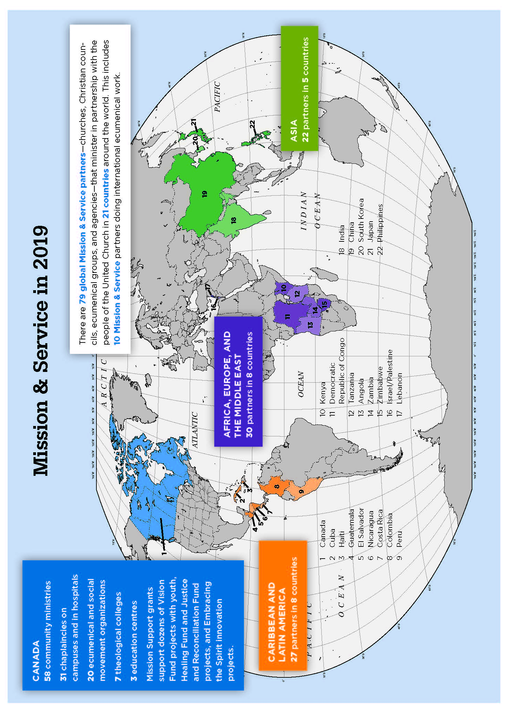

Diana Butler Bass Grateful: The Transforming Power of Giving Thanks, (HarperOne, 2018), p. 29. Used with permission.

