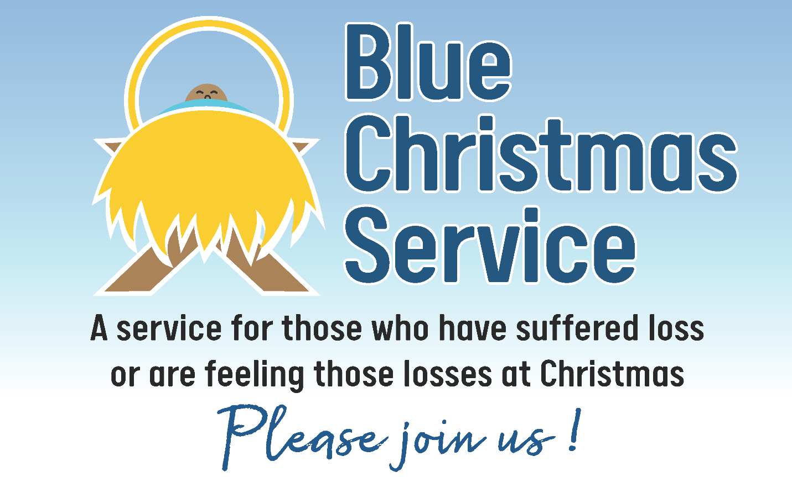
Christmas can be a difficult time if you are grieving a loss or simply feeling lonely.
Please join us at [insert name] United Church
on [insert date] 2022, at [insert time] p.m.
to be with others for a shared time to remember that we are not alone.
All are welcome.

